Alexus Lee

Summer Internship Project

Rough Draft

7/9/2025

First Day as IT Associate

This is a guide to what you will be introduced to on your first day as an IT Associate. During my first week, I spent some time at City Hall getting to know everyone there, getting a PeopleSoft/Microsoft account up along with knowing where to go. Once you get that set up, you will know the area and the people you will be working with. What you will do as an IT Associate, you are at the computer taking work orders or running around the office fixing or processing those work orders or going out in the field and helping other people and/or going to the terminal since you are working within aviation. Furthermore, every Wednesday around 2pm called the “KCAD Help Desk Support Status” meetings. Your supervisor will discuss updates on everyone’s progress within the work orders and come together as a group if a person is having issues and/or discuss other updates or announcements that we should be aware of.

The type of work you will be also doing is guiding others on how to resolve technical issues remotely. You will also be working with a ticketing system called Aerosimple. Other programs you will be using is Active Directory, Zscaler, PeopleSoft & Microsoft, etc.

* + Zscaler is how you will connect to the internet using the organization. You will need to use Zscaler and set up your username and password. Username is first initial, last name and @kci.aero. Then use your aviation network password.

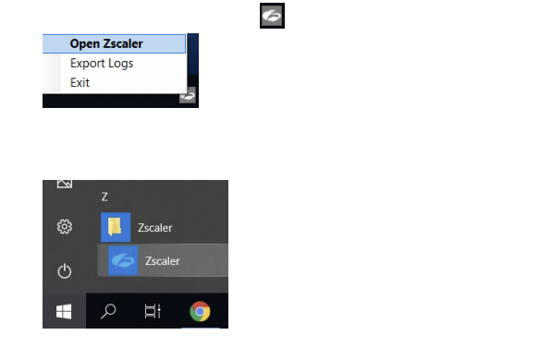

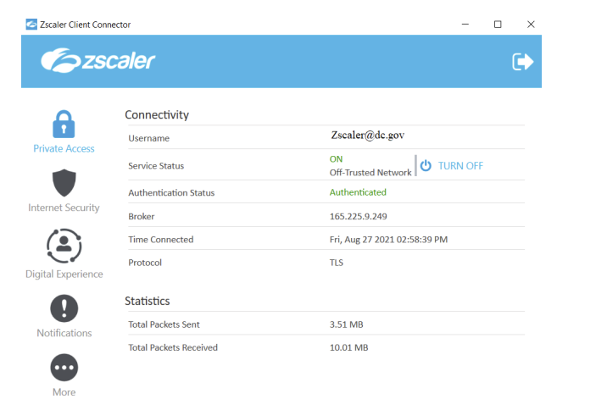

* + PeopleSoft/Microsoft: These programs are one in the same; if someone comes in or calls about this, they cannot do this over the phone, all they would do is bring an ID badge and come in person. A computer password lasts for 90 days before you need to change it. PeopleSoft & Microsoft password is 180 days/6 months before it will need to change it again.
  + Active Directory:
    1. Open the application through the search bar and type ‘Active Directory’ or 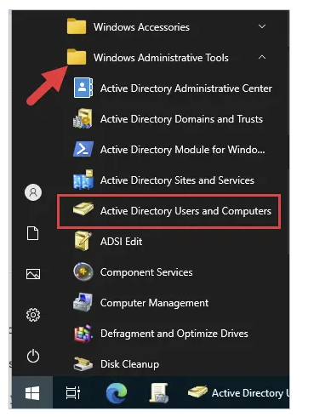
    2. You can also do the same in the application to find a user’s account. It will be under the browse the directory or search for the locked user account. 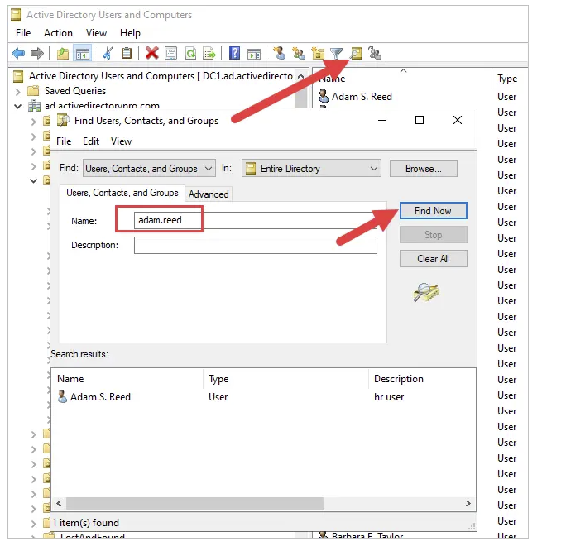
    3. Go under their department where the user is under find the person's name and right click until you find reset password. The password must be 12 characters long, with one number, one special character, no previous passwords or names, or birthday.

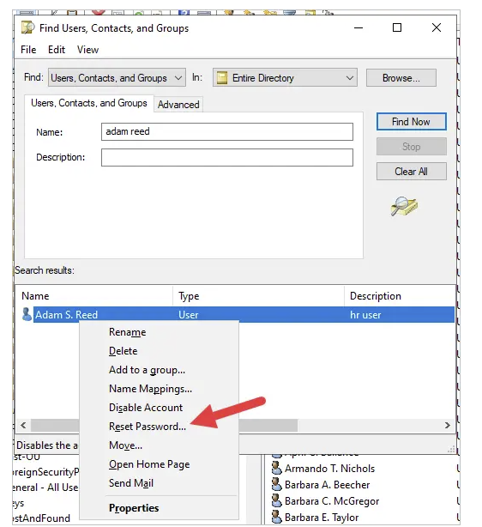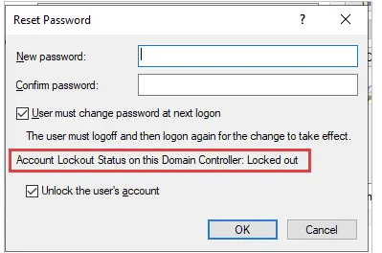

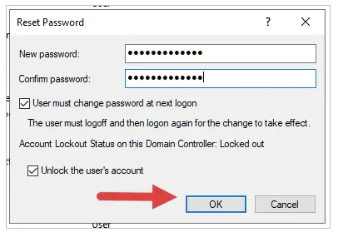

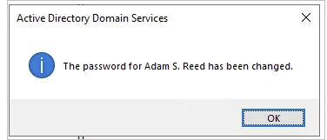

* + 1. If they are in person, they will show their badge and type their password. If they are locked out, it will show that, and you could unlock it if they asked.
    2. Also, be sure to look away as they enter their password because it shows respect and courtesy to the person you are helping.
    3. And if they are over the phone, even though they need to be in person; the temporary password will be Avitation1234. Be sure to have them test it out and write down their password so they won’t forget as soon as they go back to their department.
  + Duo Mobile: Plus, you will need to set Duo which is like a two-step verification with your computer. It should send a push message to unlock the computer. If not, there is something wrong with the server and you will need to get with someone in cybersecurity about that.
  + How do you answer the phone: When that happens, you are supposed to say,” This is the Aviation Department IT Division this is (your name) speaking, how can I help you?” Then just listen as you follow the troubleshooting method as you are on the phone with the person while putting in work order; it is that easy. Also, be sure to ask for help if you are unsure about how to help someone.
* Aerosimple (For Mobile Version):
  1. If you are on iOS, go to ‘App Store’ and search for ‘Aerosimple’. If you are on **Android**, :

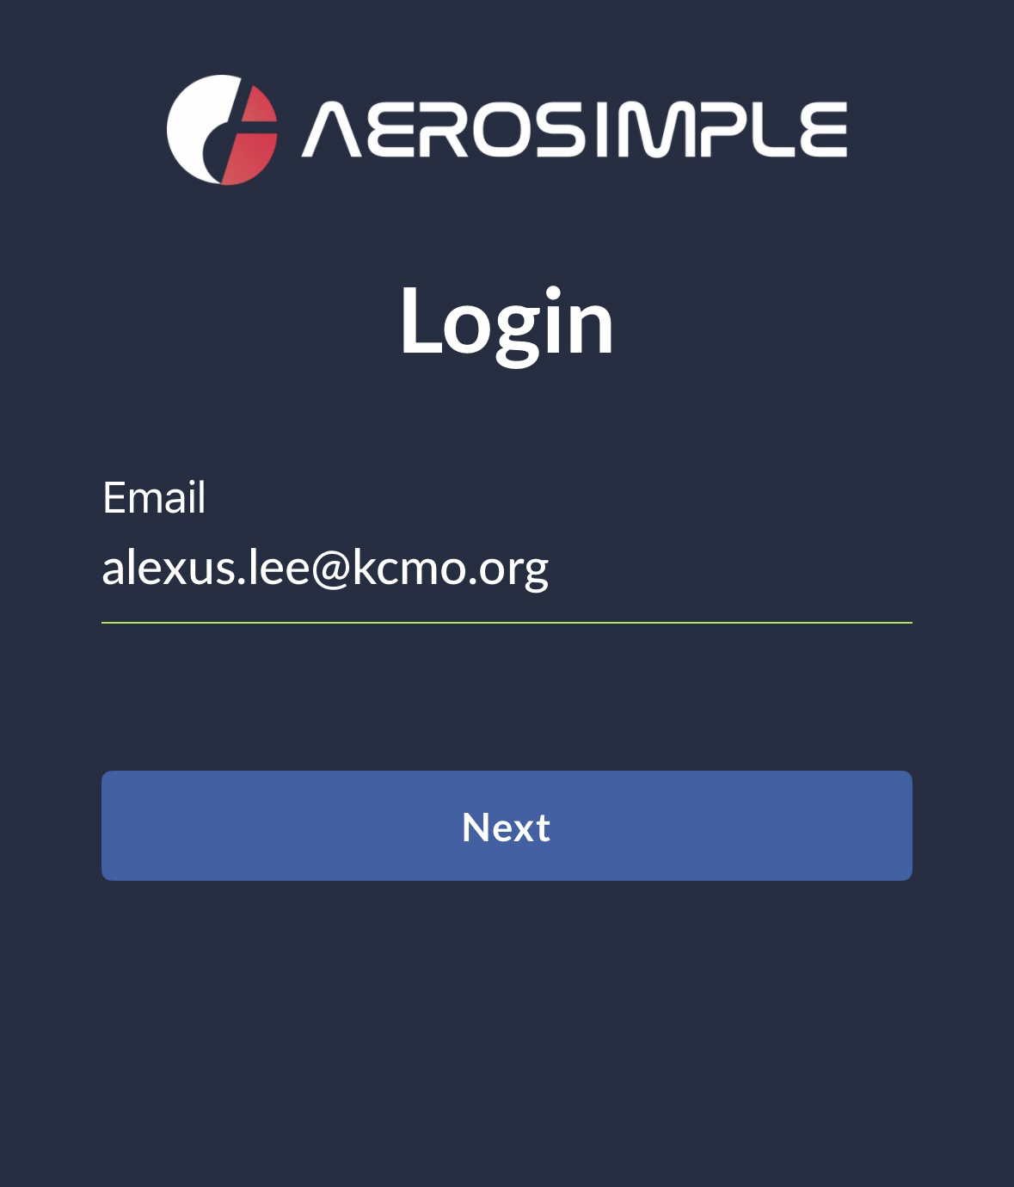

* 1. Then you put in your PeopleSoft/Microsoft email address and click next. Then click “Login with SSO”

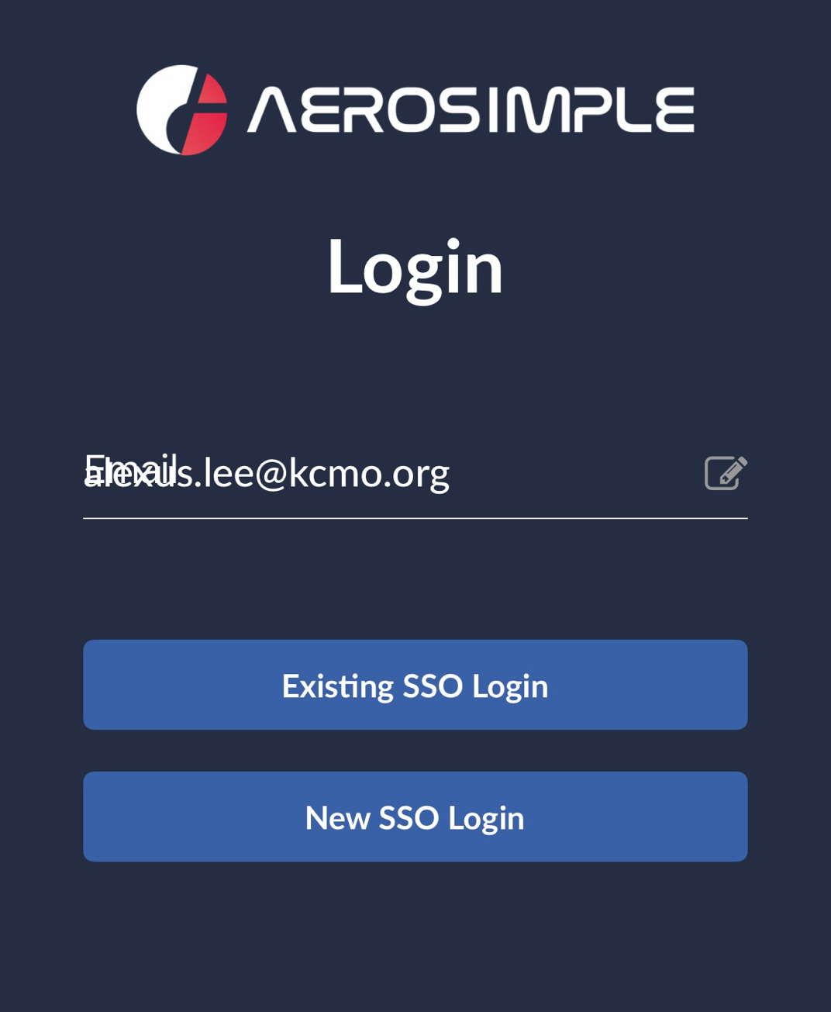

* 1. You will be redirected to the Microsoft login page for authentication. Enter your Aviation credentials with @kci.aero behind them. These are the same credentials as logging into Zscaler. Then click next. Enter your Aviation network password. Click Sign In. This will log you into Aerosimple.

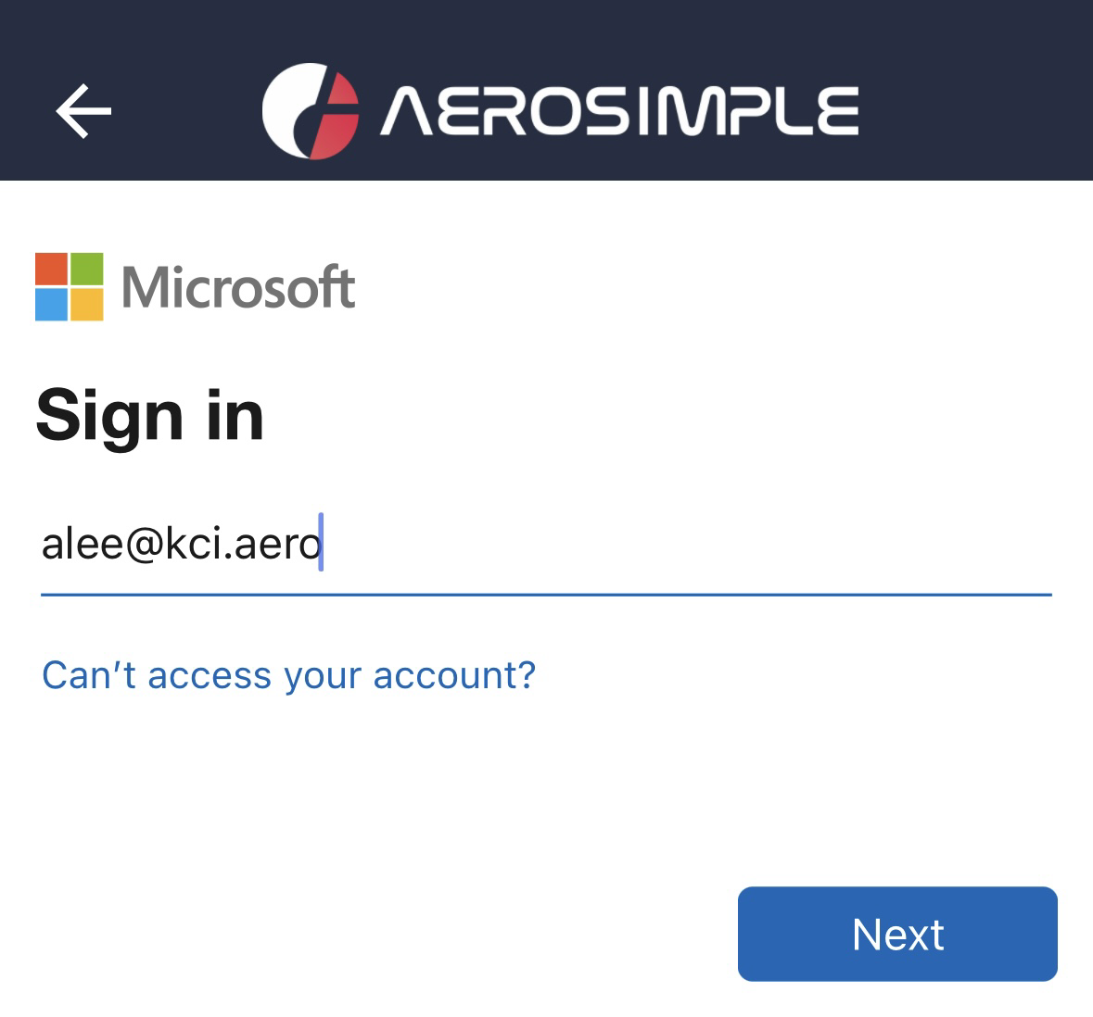

* 1. Once you are there, you click on “Apps” in the top left corner, go down to “Work

Order” then go to “Non-Airfield Work Orders”. Be sure to star it/add to favorites because you will be using it a lot.

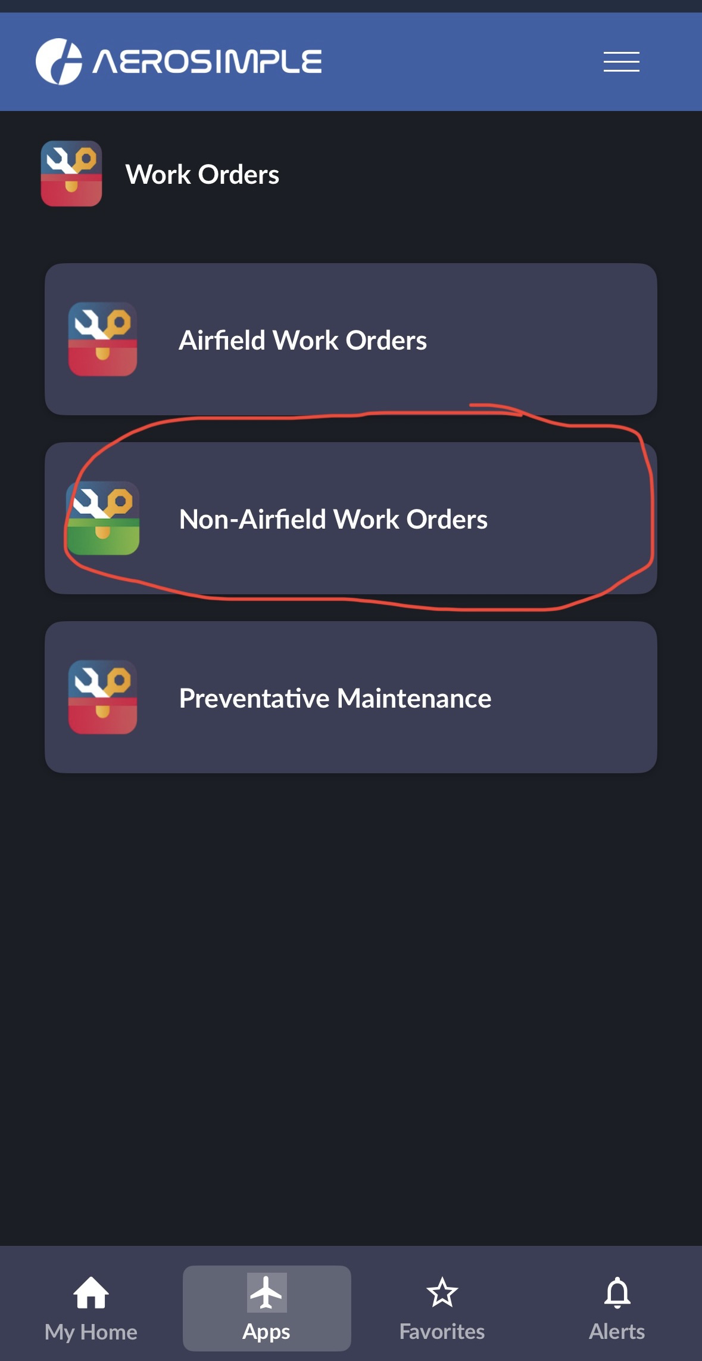

* 1. Then once you are in “Non-Airfield Work down to “Category” until you find “Information Technology Services” click and scroll up to “Apply”. The work order will look a lot less than what it previously did.

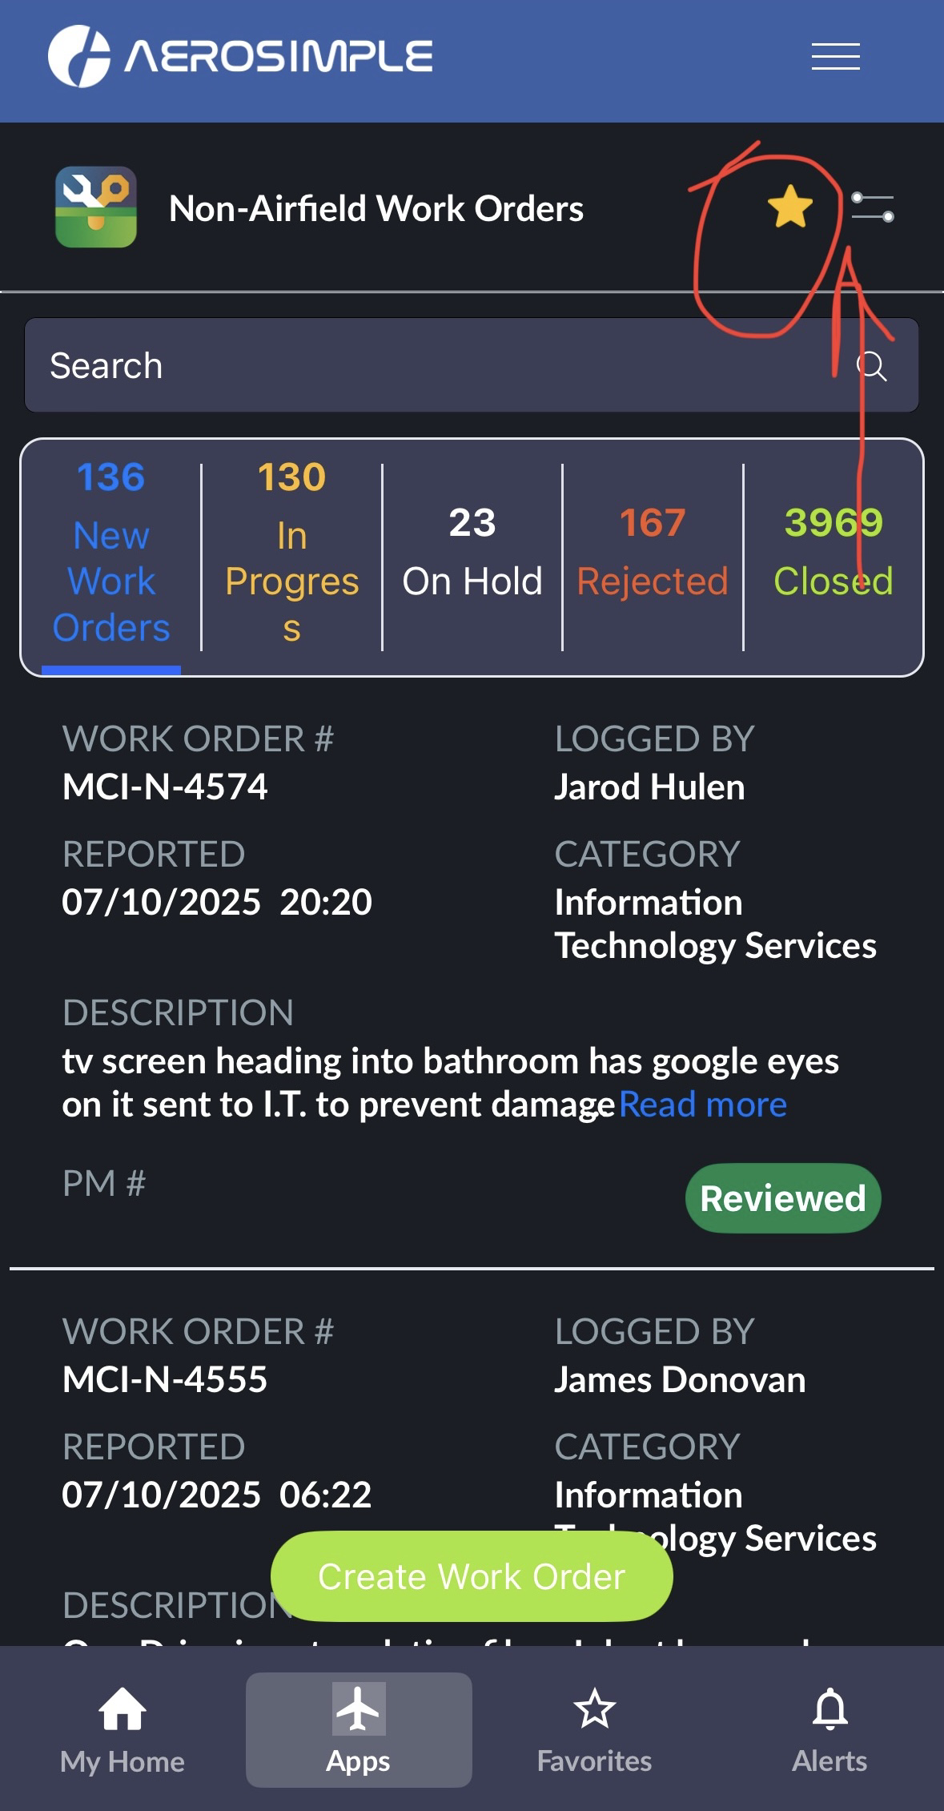

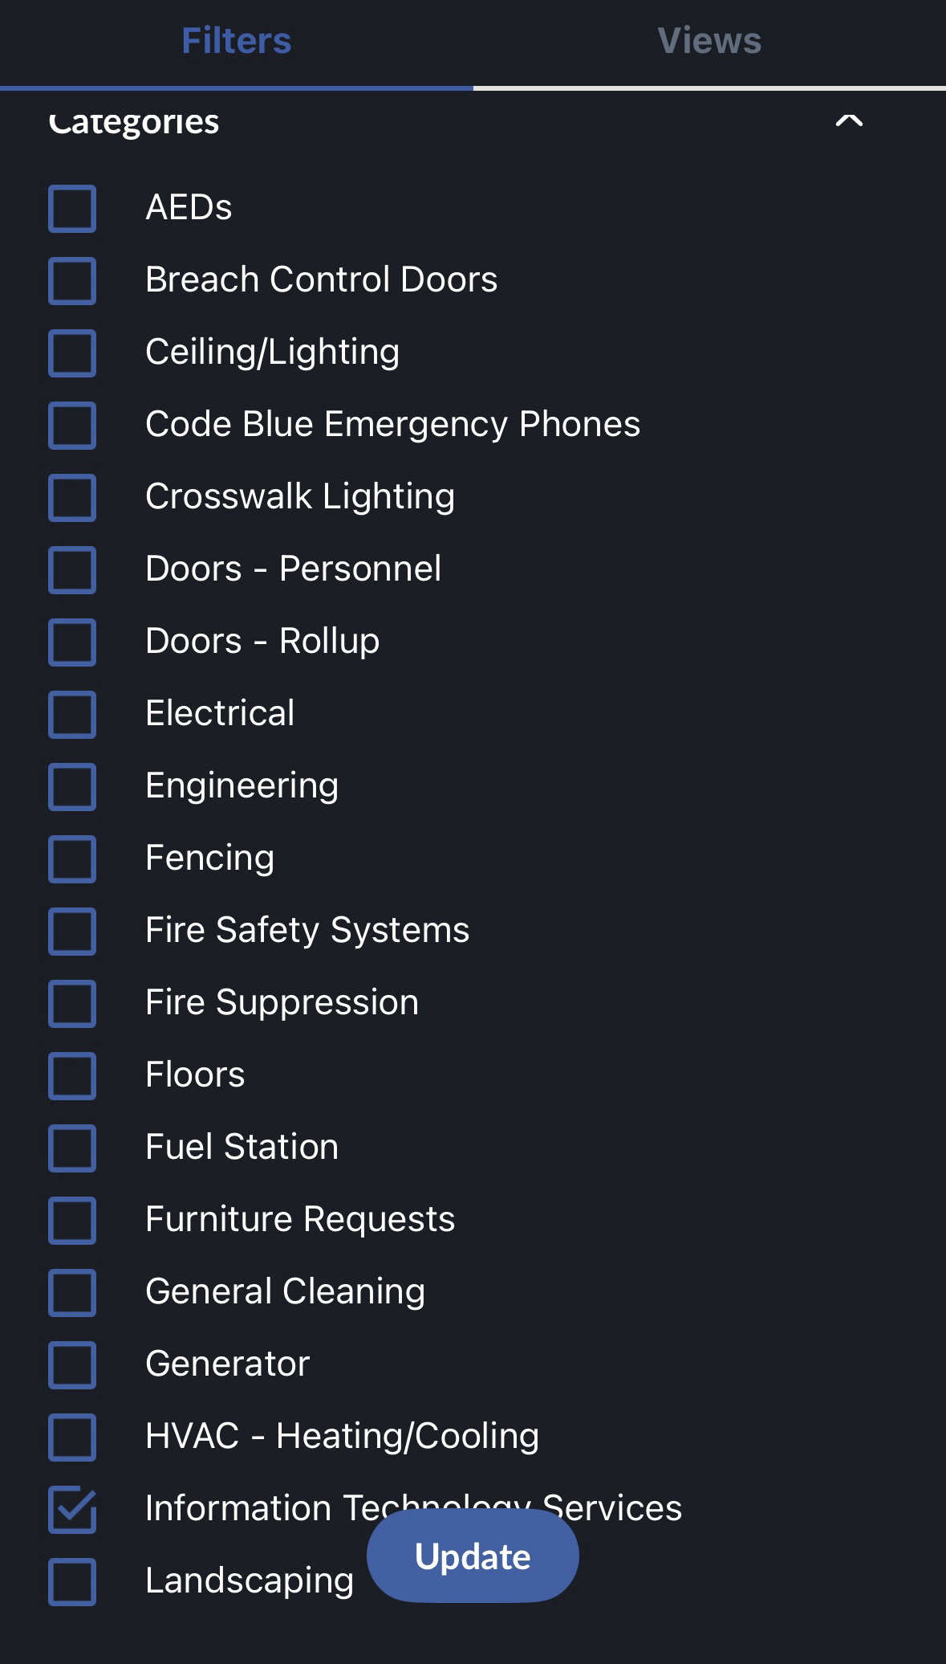

* 1. When creating work orders, you can have it “In Process” meaning it is still being worked on. “On Hold” means it is awaiting parts for an order.
  2. “Rejected” because we cannot do anything about it or they assigned it to the wrong area.

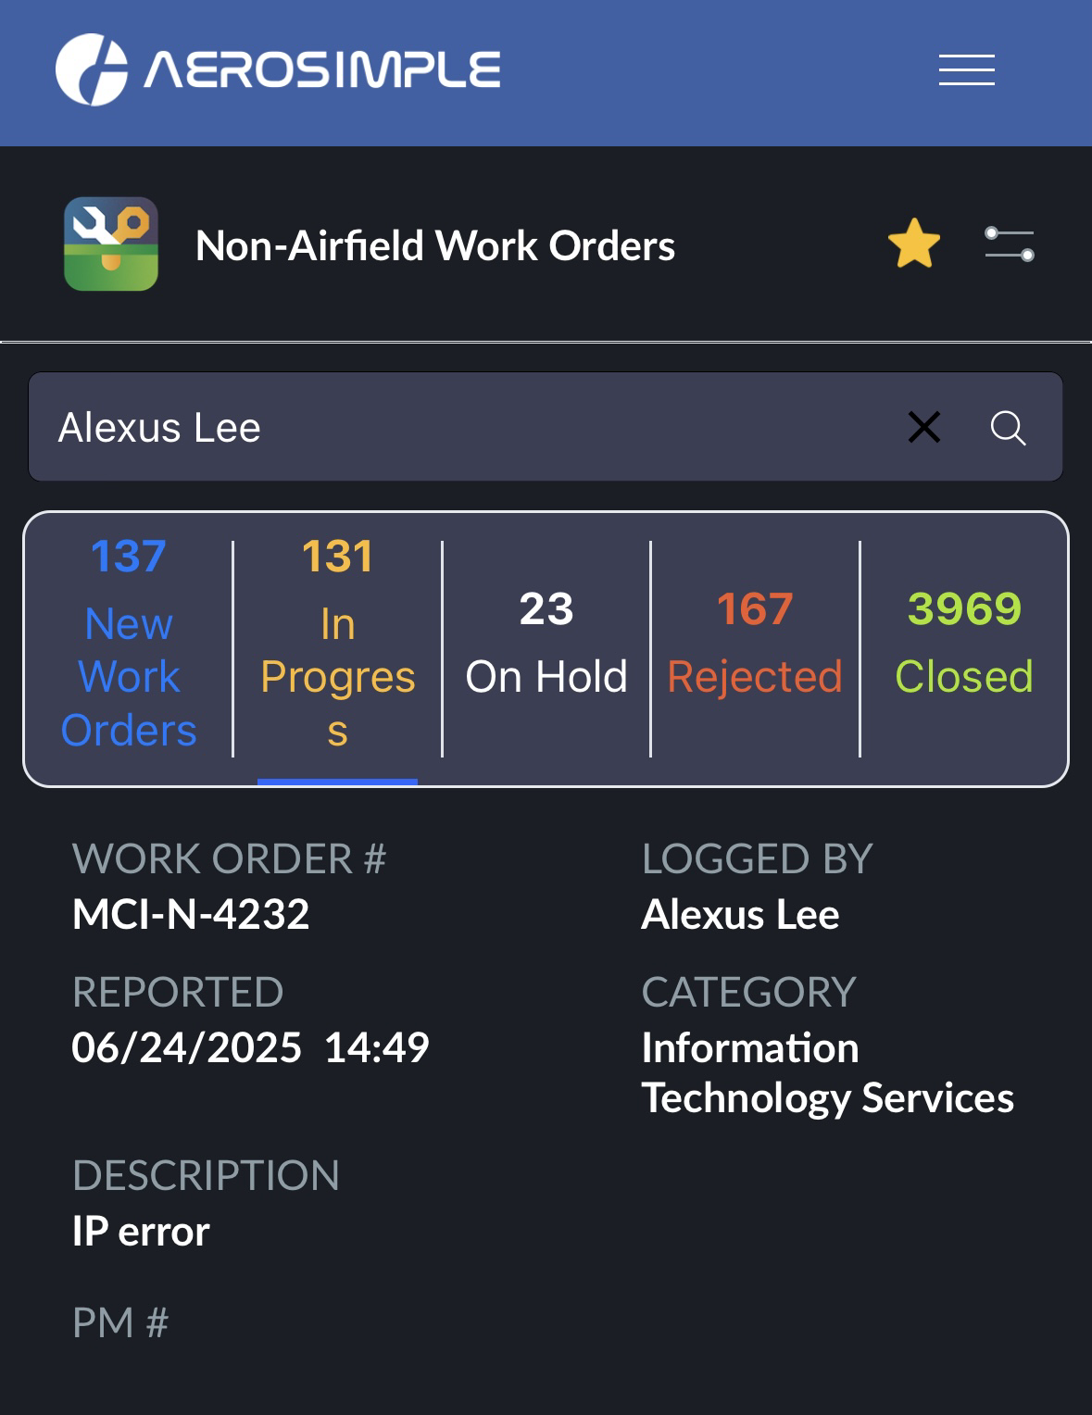

* 1. And “Closed” means it has been completed.
  2. Once you answer the phone, state “This is the Aviation Department IT Division, you are speaking with so and so, how can I help you?” You listen as you follow the troubleshooting method or whatever concern the person might have. Once you fill out the page, click Create.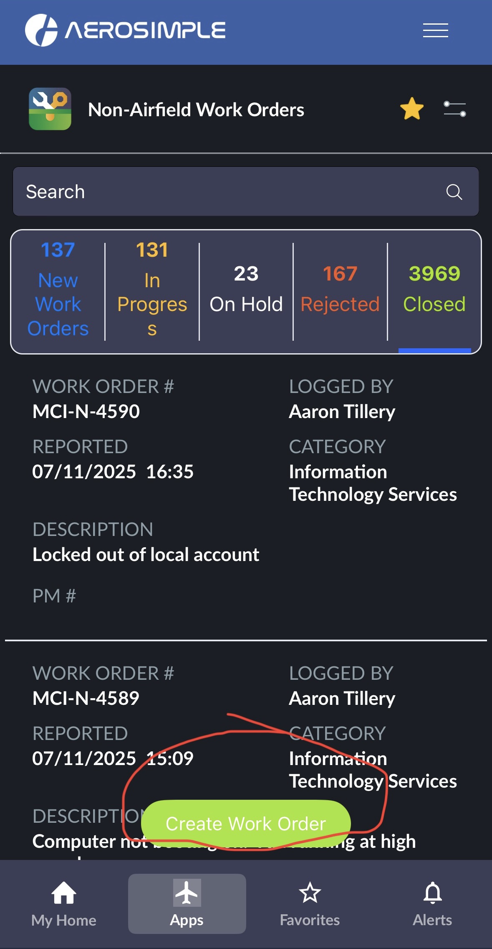

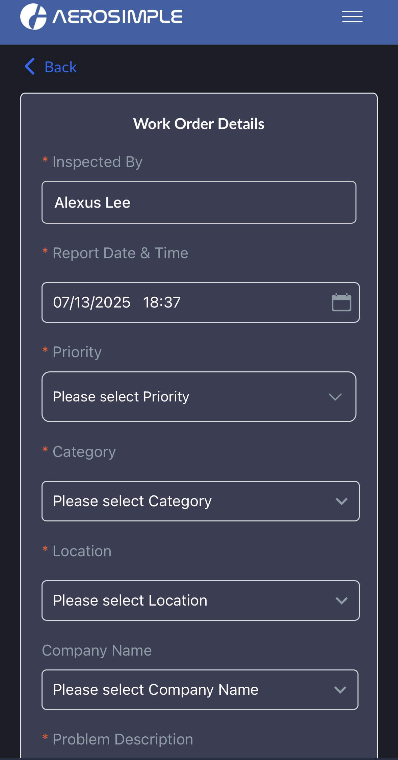

* 1. When you create the work order, you fill out the information that is in red. For instead:
  + Reported By
  + Tenant or Company
  + Phone Number
  + Requester Email
  + Problem Description
  + Locations
  + Priority
  + Category
    - Information Technology Services
      * Subcategory
* When it comes to the priority levels, low is for password resets like for computer or PeopleSoft/Microsoft resets usually that can wait seven business days. Medium is usually the go-to to and it can be done in three business days.

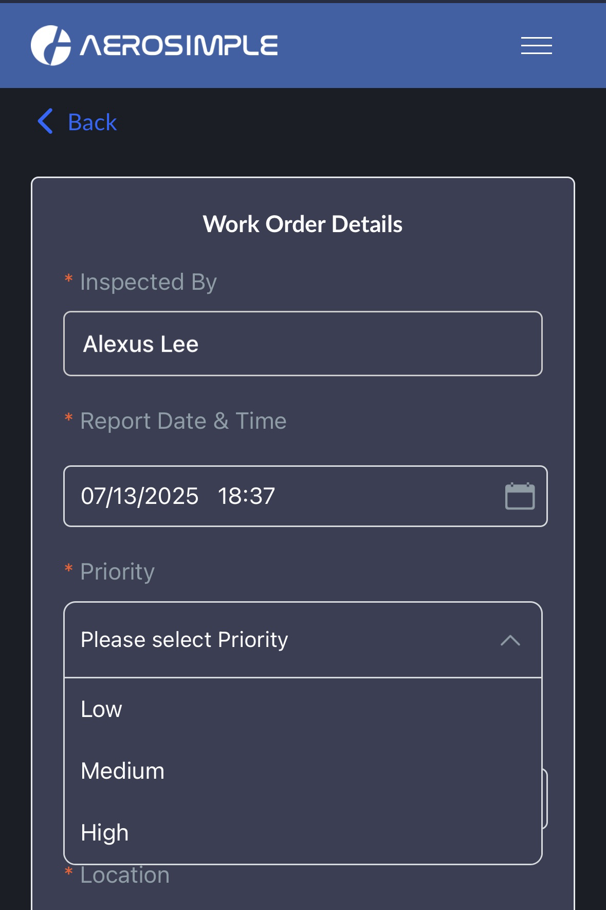

* 1. For example, connecting two devices for a meeting or an issue with Duo Mobile, or not viewing the printer queue from the desktop for medium priorities. When it comes to high priority, it needs to be done on the same day. For instead, if the police department’s computer is not working and they are trying to monitor incoming travelers in the Terminal building at the airport. This would be a high priority, but this is a rare possibility.

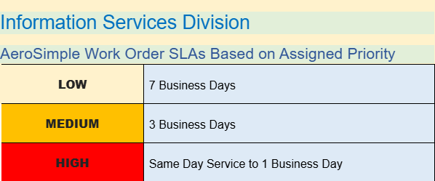

* + - Be sure to click “All Data” found in “Table View” then click Apply. So, it can pull up all the recent data.
    - **Asset Registry for mobile version**
* Aerosimple (Desktop Version):
  1. Go to app.aerosimple.com/auth/login and type in your city email address and click ‘Next’:

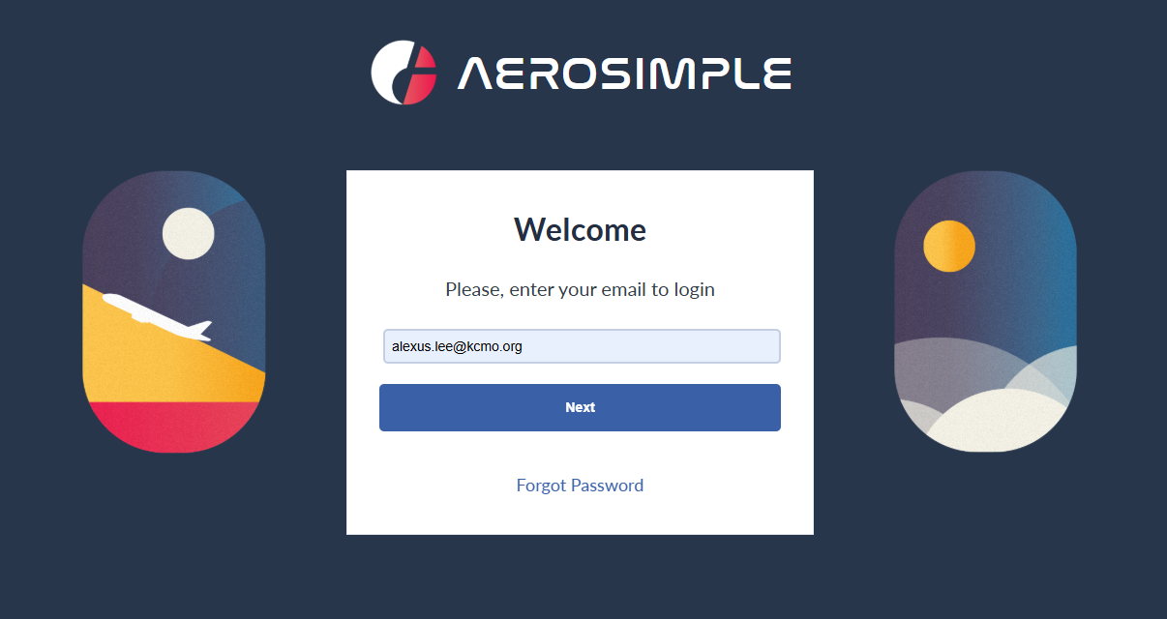

* 1. Resume by clicking the “Login with SSO”. You will be redirected to Microsoft authentication to re-login.

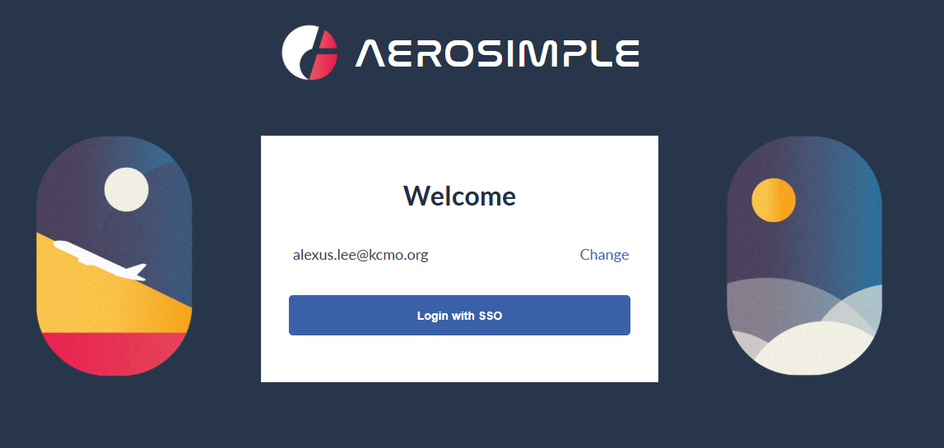

* 1. You will enter your Aviation credentials with @kci.aero along with your Aviation network password. Then you should be able to get to Aerosimple.

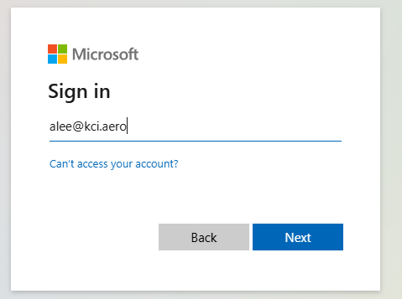

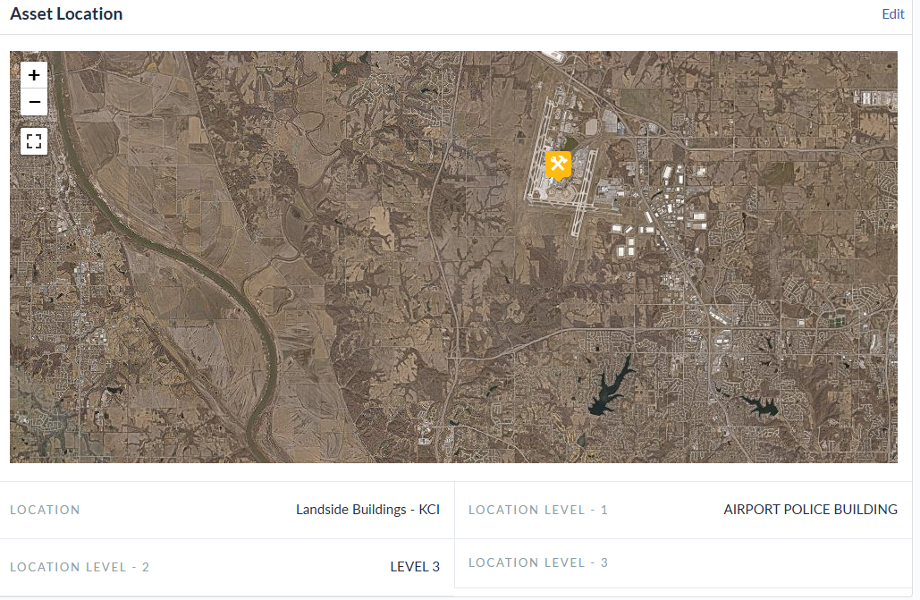

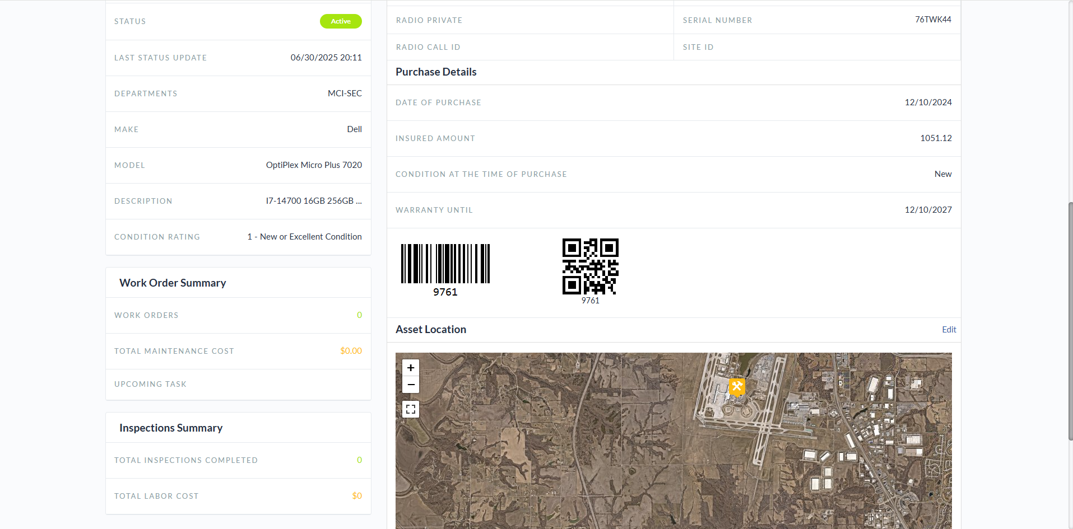

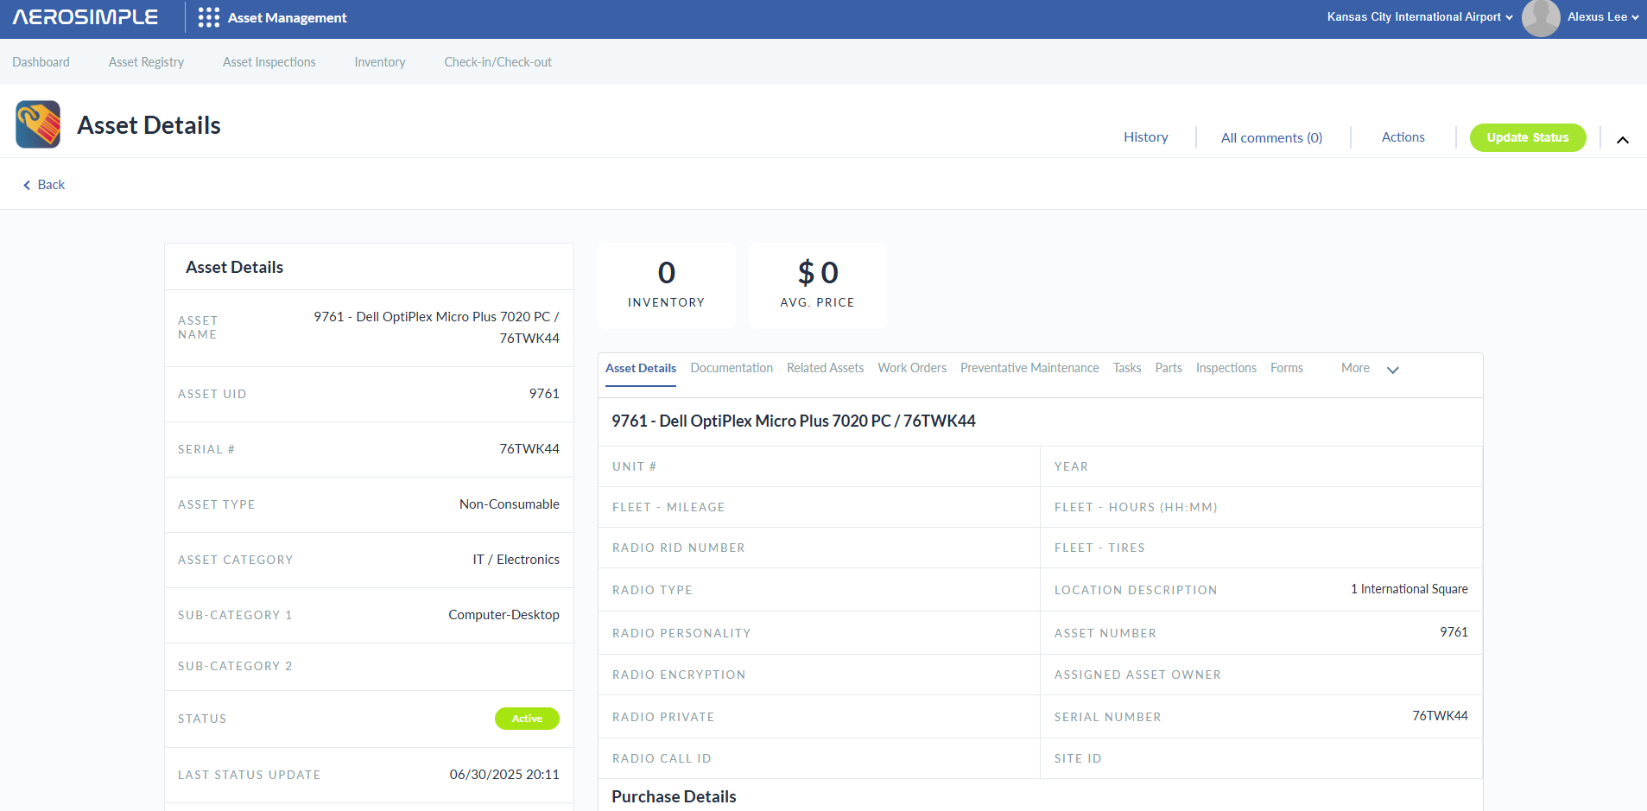

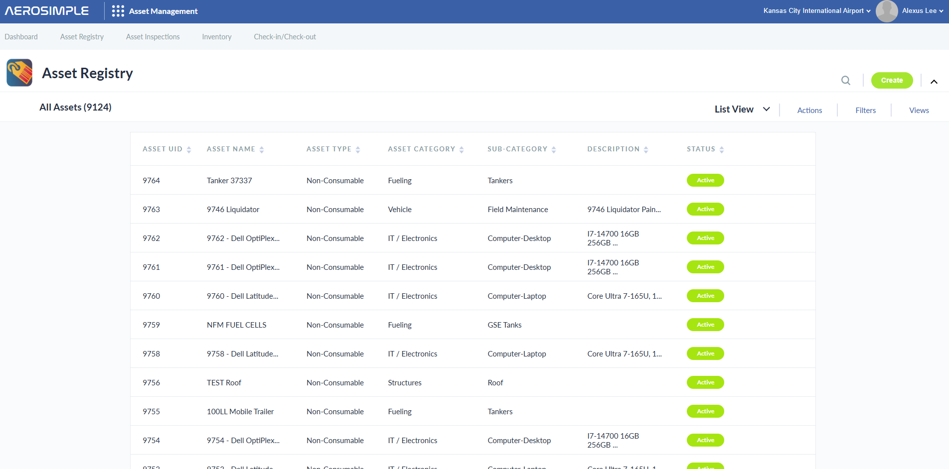

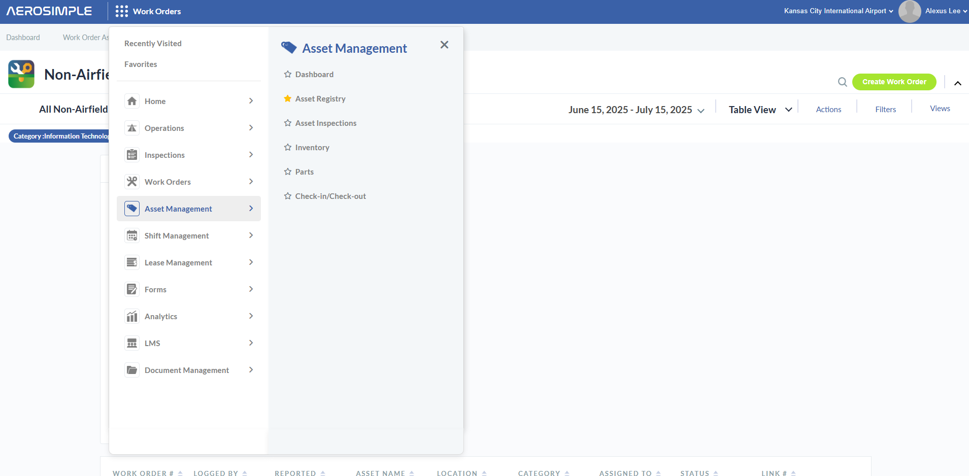

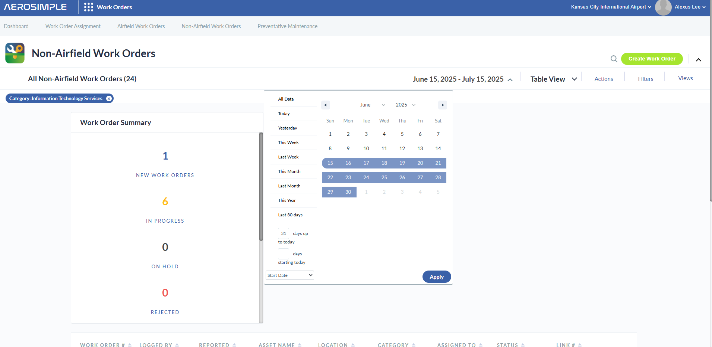

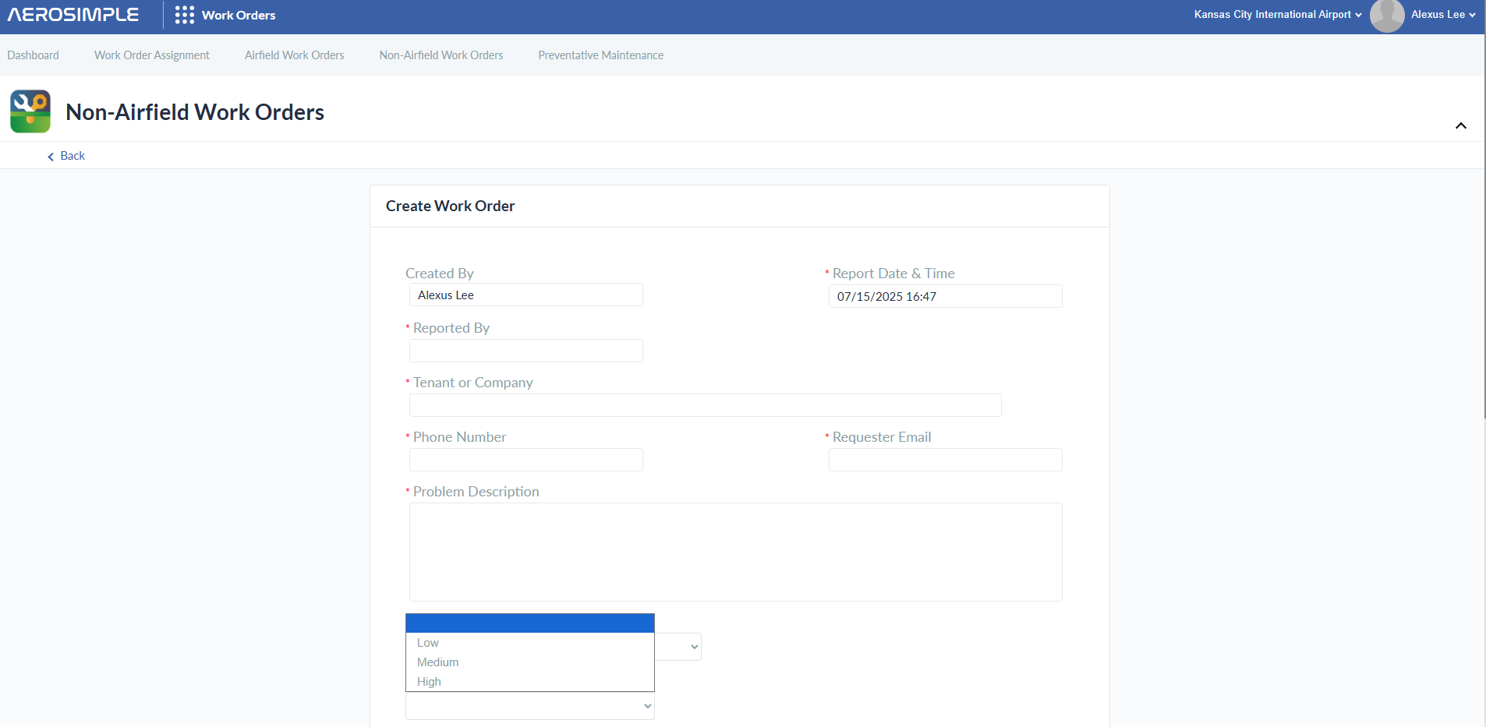

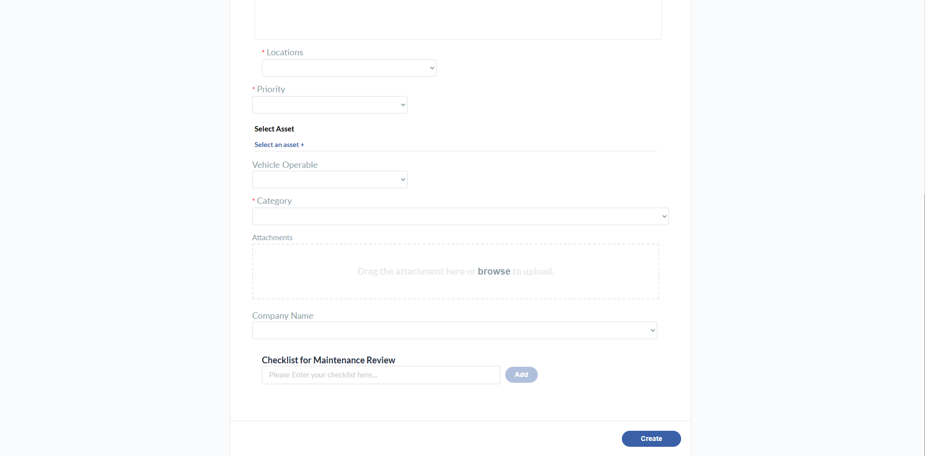

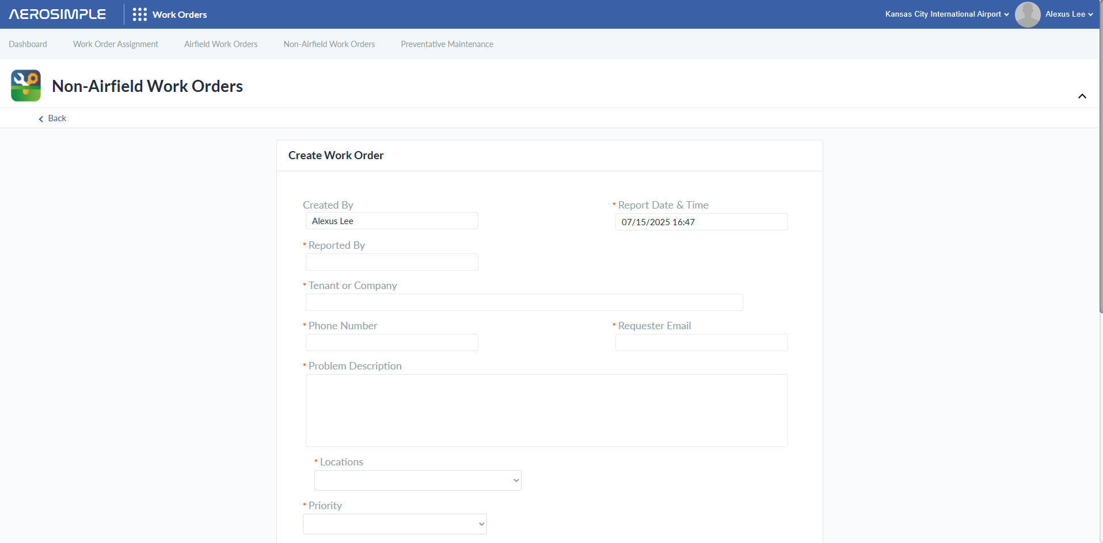

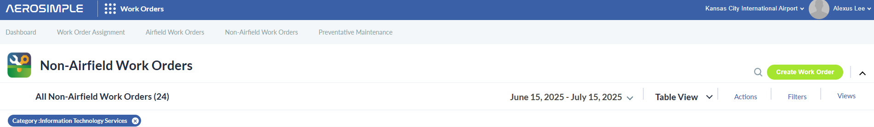

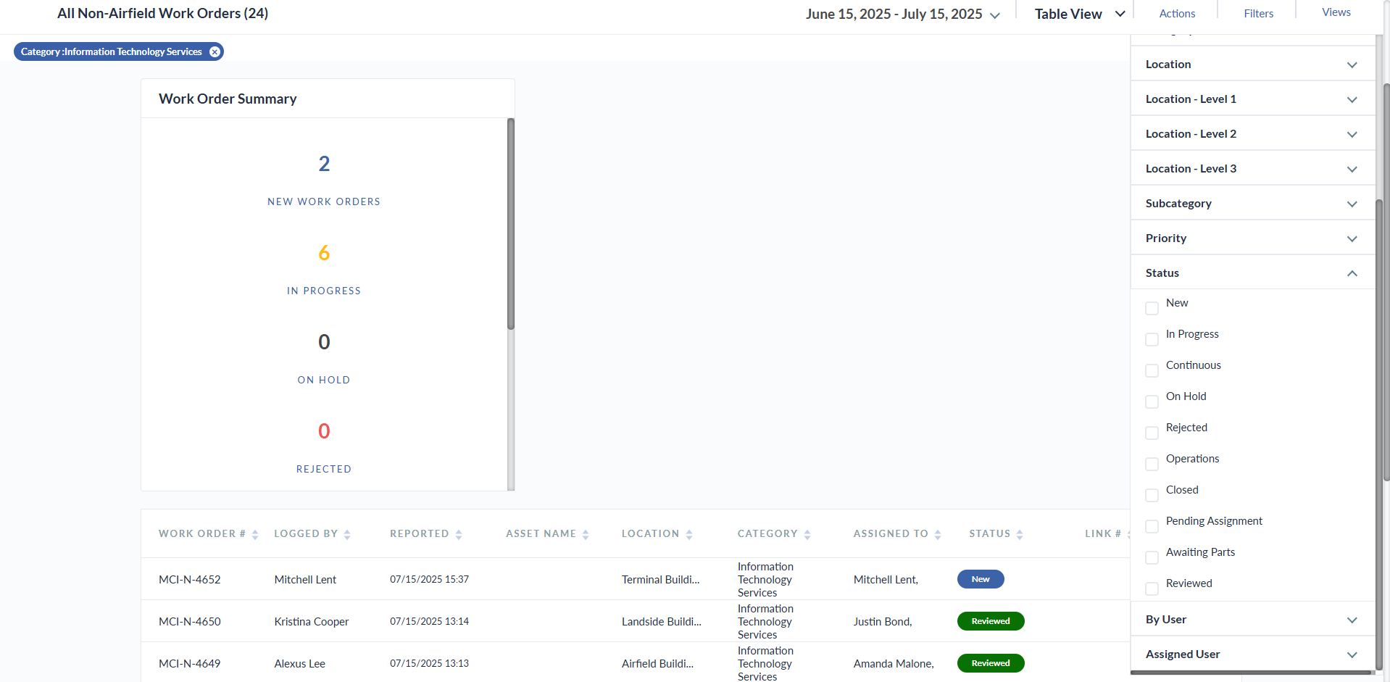

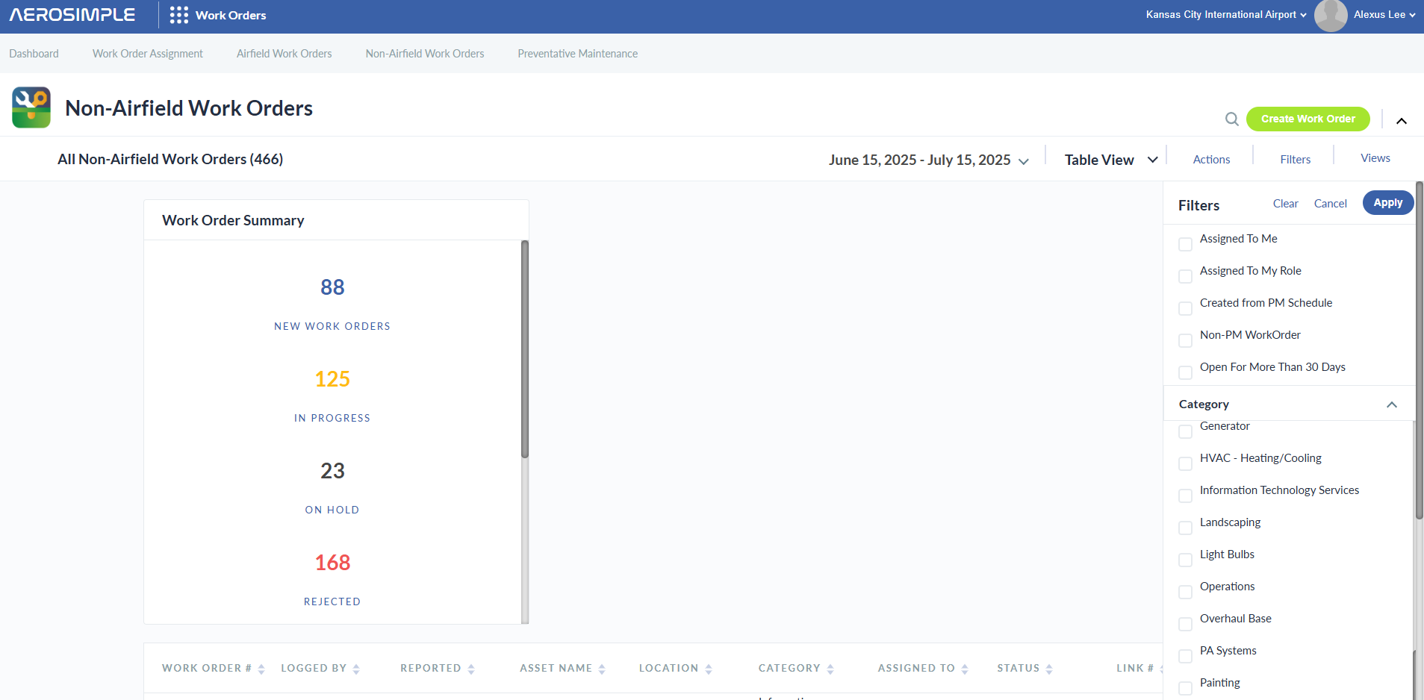

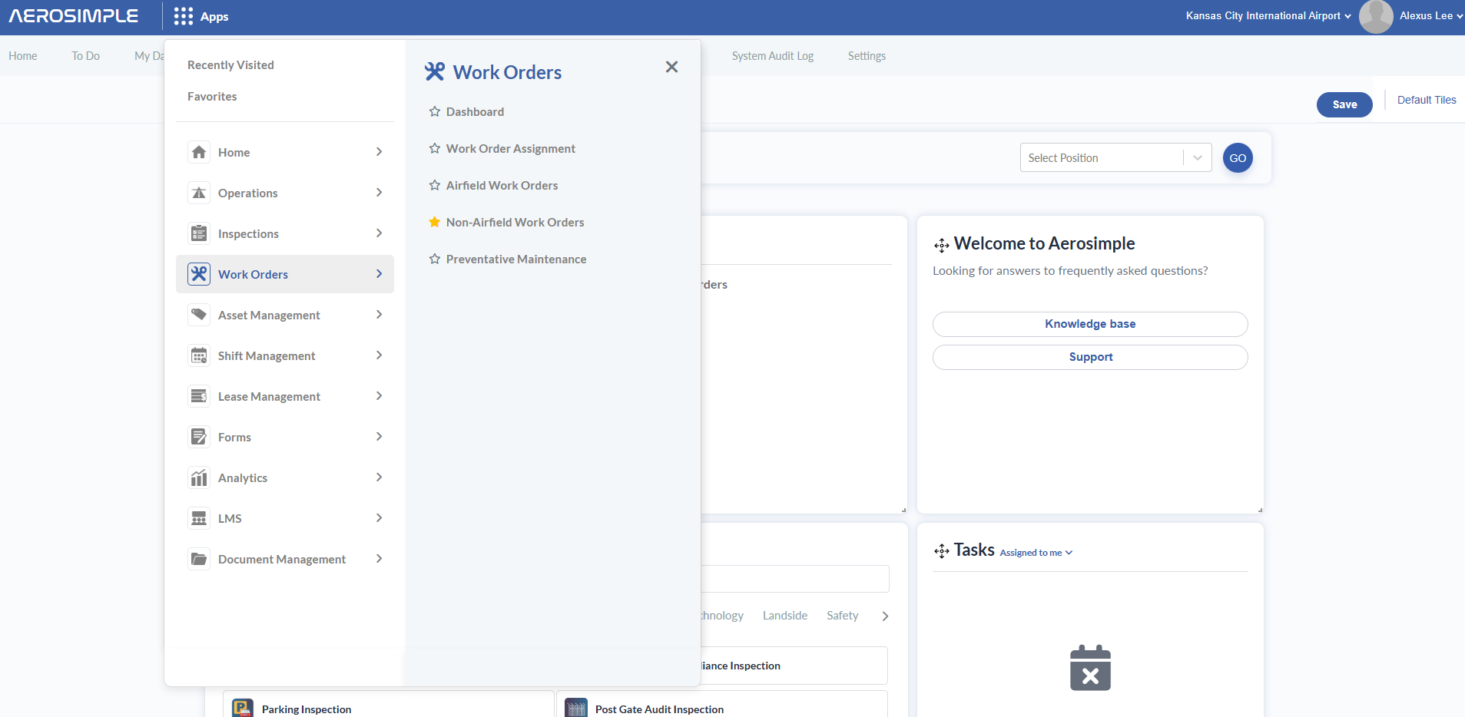

* 1. 